**Hands-On Lab/Demo Script**

**Java Development on Linux with Visual Studio Team Services**

# Exercise 8: Releasing your applications

Lab version: 1.1.0

Last updated: 3/7/2016

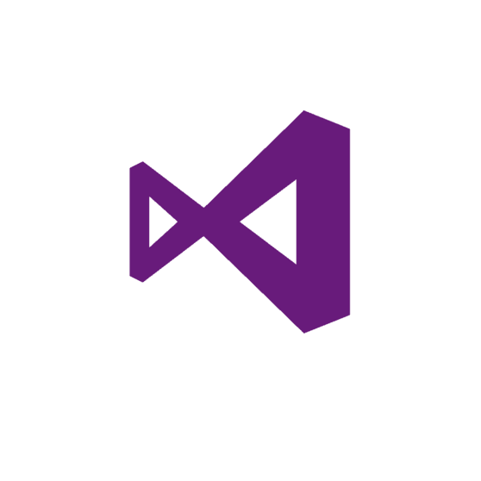

A big pain for any development team is getting changes made on a developer’s workstation deployed to a dev, test, or even production environment. Release Management makes it easy to take the results of a successful Team Build and deploy them to one or more environments.

Release Management is a service in Visual Studio Team Services and Team Foundation Server (update 2 and later) that helps you automate the deployment and testing of your software in multiple environments. Using Release Management, you can either fully automate the delivery of your software all the way to production, or set up semi-automated processes with approvals and on-demand deployments. It is an essential element of DevOps that helps your team continuously deliver software to your customers at a faster pace and with lower risk.

Before you start to write your release definition, you will need to install the **Tomcat** extension. When you install the extension, it adds a Build/Release task for deploying a WAR file to Apache Tomcat Server.

## Adding Tomcat Extension

1. From your Team Services account, go to the marketplace or go to  <https://marketplace.visualstudio.com/#VSTS>
2. Under the **Build and release category**, select **See more**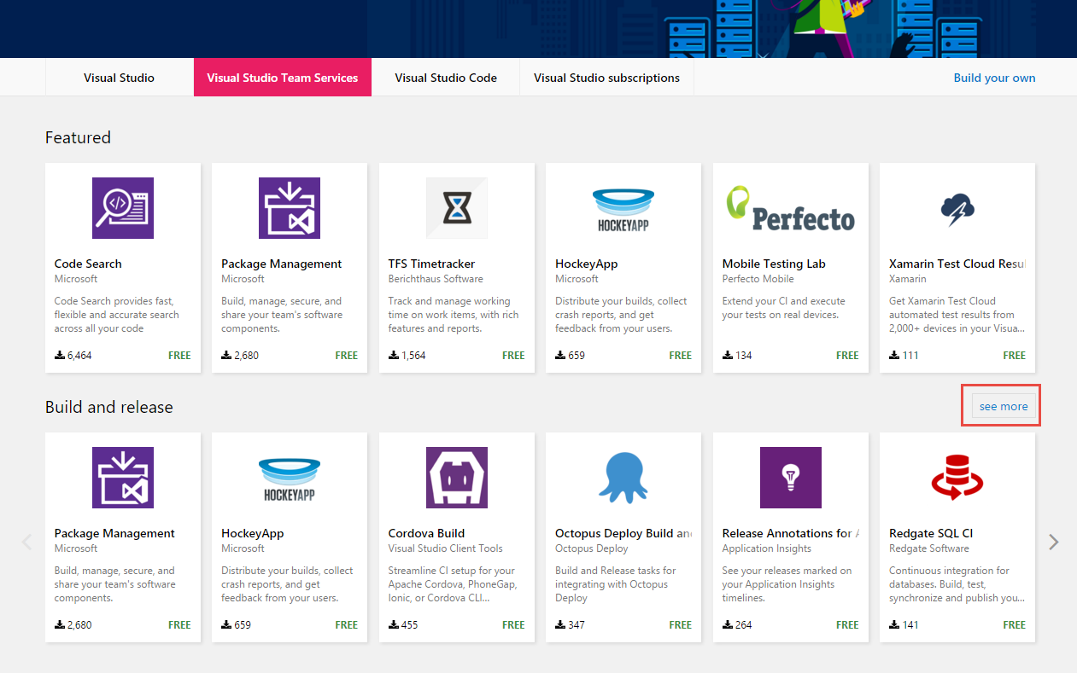
3. Look for the extension titled **Apache Tomcat Deployment** and select it  
     
   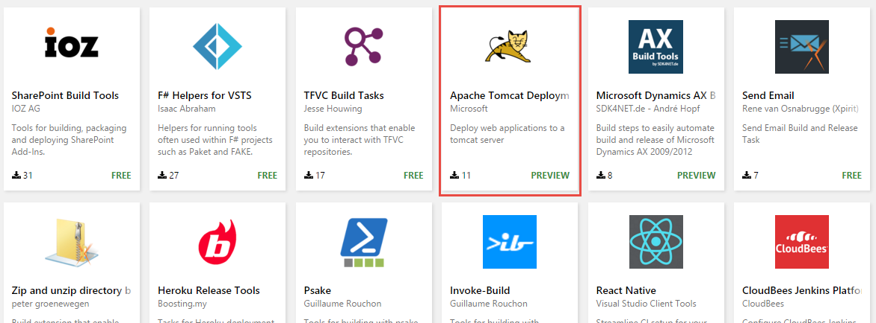
4. Select **Install** on the Extension home page  
     
   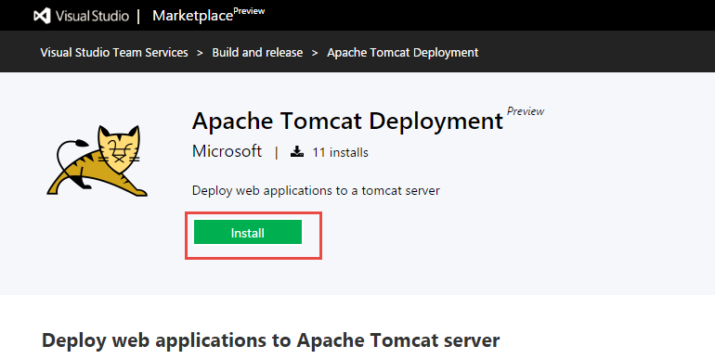
5. In the resulting page, click the Account field to select the account name where you want to install the extension  
   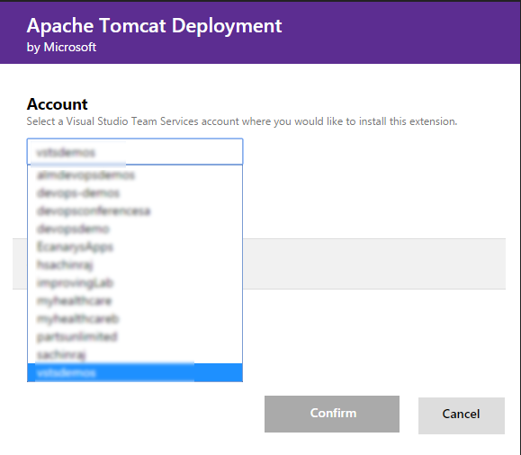
6. Select **Confirm**. Once the extension is installed, you can close the page and navigate back to your VSTS project

## Creating a new release definition

1. In VSTS, access the **Build** Hub of your Team Project. Select the **Manual Build** and queue a new build.

If you want to skip the tests, you can specify -Dmaven.test.skip=true in the **Options** parameter

1. When the build is complete, ensure that the build has generated and published the WAR file. You can verify this by select the build and then selecting the **Artifacts** tab. Click the **Explore** link next to the folder **Site**. Expand the folder and you should see **MyShuttleDev.war**

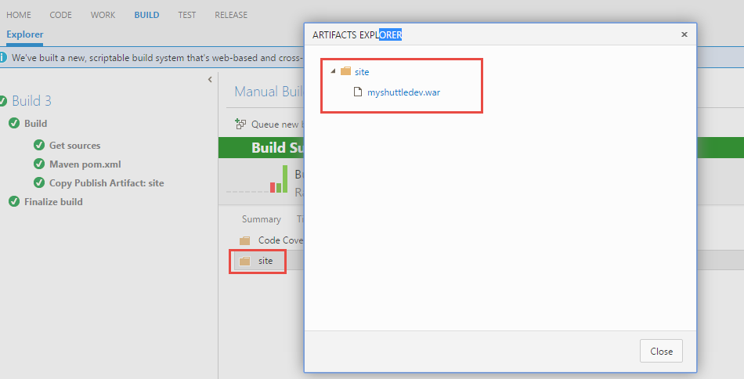

We are now ready to release the WAR file to the Tomcat server running on the VM. To begin this, select the **Release** hub.

1. Click the **here** link or the **Green +** icon to start creating a Release Definition.

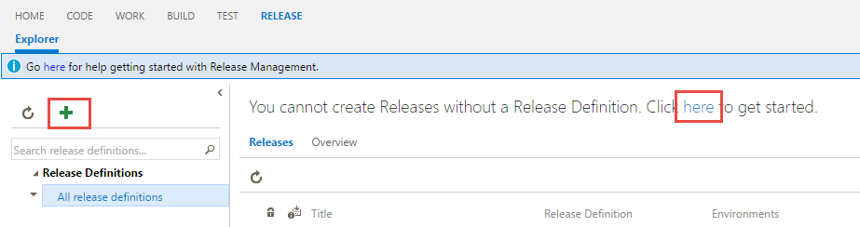

1. Choose the **Empty** definition and click **OK**.

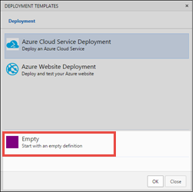

1. Set the Name to **MyShuttle Release.**
2. Click **Add Tasks** and choose **Deploy to** **Apache Tomcat** task from the group and click **Add**.

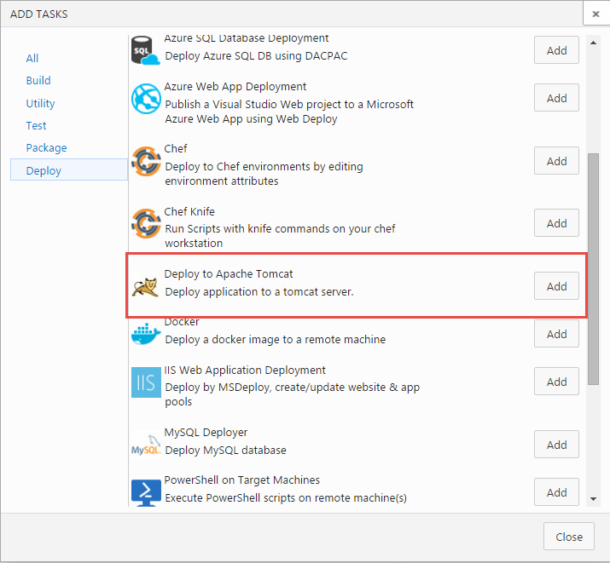

1. Click **Close**.
2. Before we edit the **Tomcat** task, you will need to link the release definition to the build definition. Select **Artifacts** tab and select the **Link an artifact source**. You should see the ***Manual Build*** as the Source (Build Definition).

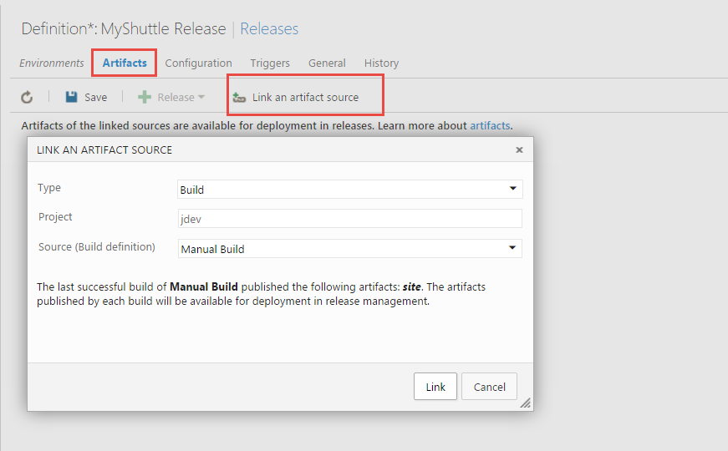

1. Select **Link** to create the link and close the dialog
2. Return to the **Tomcat** task and edit the parameters to match the following settings:

|  |  |
| --- | --- |
| **Setting** | **Value** |
| Tomcat Server URL | http://localhost:8080 |
| Username | vmadmin |
| Password | $(VM_PWD) |
| WAR File | $(System.DefaultWorkingDirectory)\Manual Build/site/myshuttledev.war |
| Application Context | /myshuttledev |
| Tomcat Server Version | 7 or above |

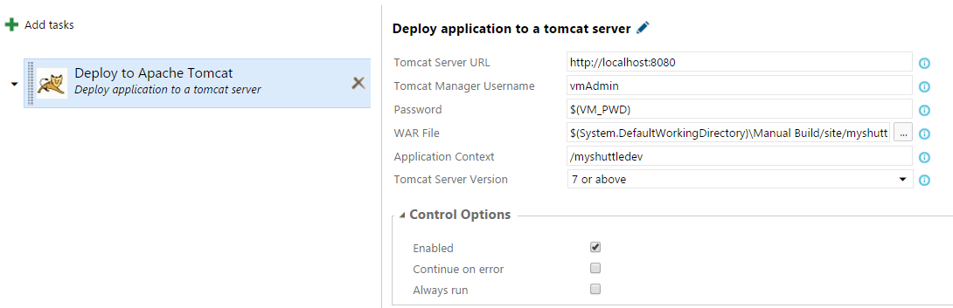

1. Let’s define the variable we used in the task. Select **Configuration** and enter **VM_PWD** as the name for the variable and **P2ssword** as the value. Select the little lock icon next to the value field to hide the variable so that it is not displayed as plain text.

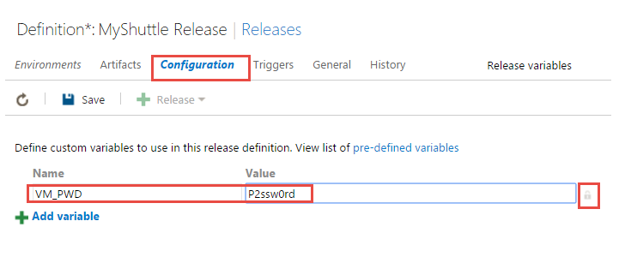

1. Now, let’s go back to the **Environments** tab. Select the Default Environment and click the ellipsis button and select **Agent Options**.

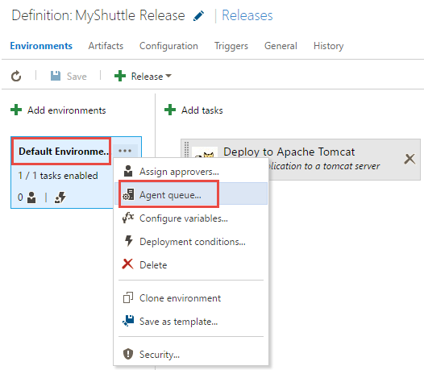

1. Select the **Default** pool (that has the local build agent running on the VM) as the default queue

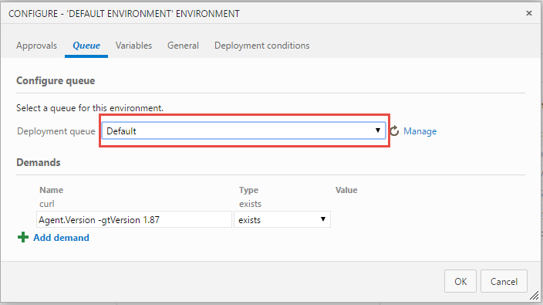

You may also assign approvers for post and pre deployment to the environments but since we are deploying to a development environment, we will assume that no approval is required and leave it as automated.

## Triggering a release

You can specify how deployment should be triggered for each environment. For example, you can set up a linear pipeline where a release is deployed first to the **Dev** environment, then to the **QA** environment and finally, if the deployment to **QA** succeeds, to the **Prod** environment. Alternatively, you can set up a release process where a build is deployed to a number of **QA** environments in parallel as soon as it completes, but the release to the **Prod** environment must always be deployed manually by selecting a successful release and promoting it.

1. Select **Deployment Conditions** for the Default Environment.

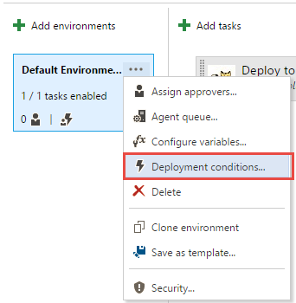

1. Select **After release creation** for **Triggers** and click **OK** to close the dialog

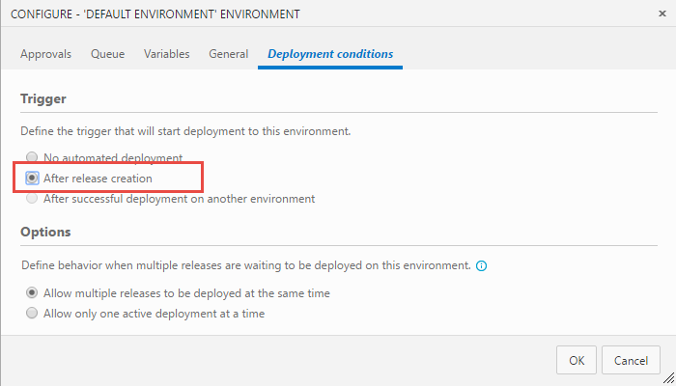

1. Select the **Save** button to save the new release definition. Select **Release** and **Create Release**

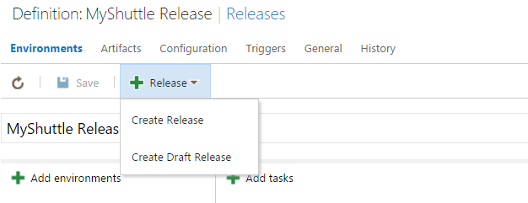

1. Select the latest build from the Artifacts Version dropdown and select **Create**

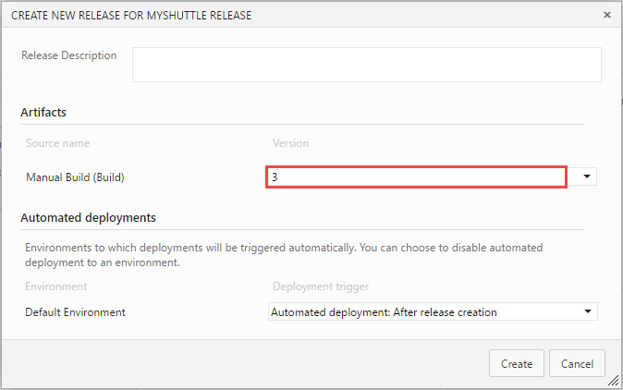

Wait for the release to be completed. When the release is successful, we should have the latest version of the application with a new UI look running on tomcat. Open Firefox in the VM and navigate to the page **http://localhost:8080/myshuttledev**

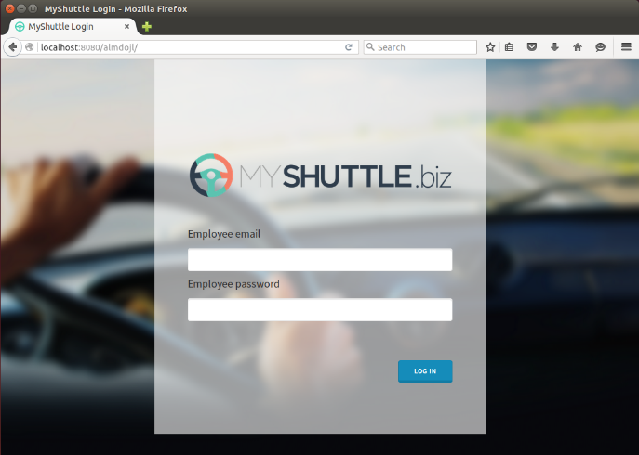

To give feedback please write to [devopsdemos@microsoft.com](mailto:devopsdemos@microsoft.com)

Copyright © 2016 by Microsoft Corporation. All rights reserved.